* Iris Normalization:
  + Why?
    - Pupil diameter changes in lighting.
    - Normalized from circular to rectangular
  + Changes coordinates from cartesian to pseudo-polar.
* Iris Encoding
  + Define: Extracting a feature vector from the normalized iris
  + Summary:
    - The normalized iris image is subjected to filtering
    - The phasor response of the filter imaged is examined
    - Two bits are assigned to the pixel based on the sign of the real and the sign of the imaginary components of the phasor response
    - Resulting feature vector is called the iris code.
  + Apply filters called gabor wavelets.
    - Complex values. (Complex gabor wavelet)
  + Filtering Equation
    - Captures information at a certain frequency

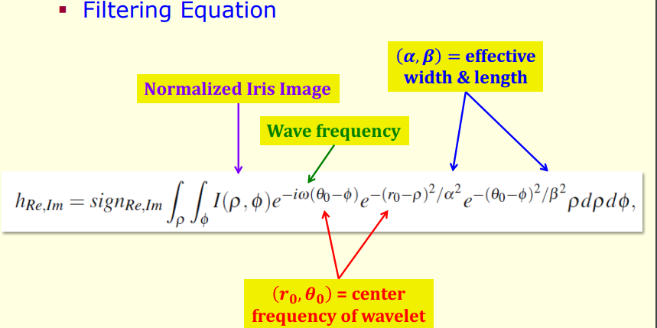

* + Assigning the bits
  + 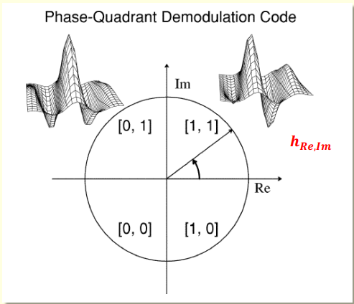
* Iris Matching
  + Summary
    - Match two iris codes using normalized Hamming Distance (HD)
    - Use masks to account for occasions
      * Mask has value “0” for non-iris pixels
      * Mask has value “1” for iris pixels
  + Iris code: rectangular
  + Iris masks
  + Both binary matrices
* Normalized Hamming Distance (HD) [Exam Question]
  + 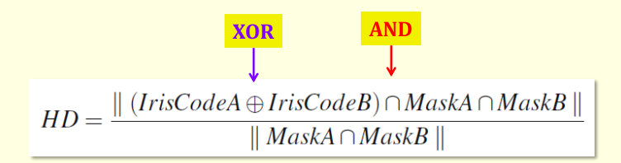
  + Numerator: counting the number of bits that are different corresponding to the iris-only pixels (the mask excludes non-iris pixels
  + Denominator: counting the number of iris-only pixels in both the images

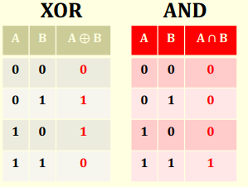

* 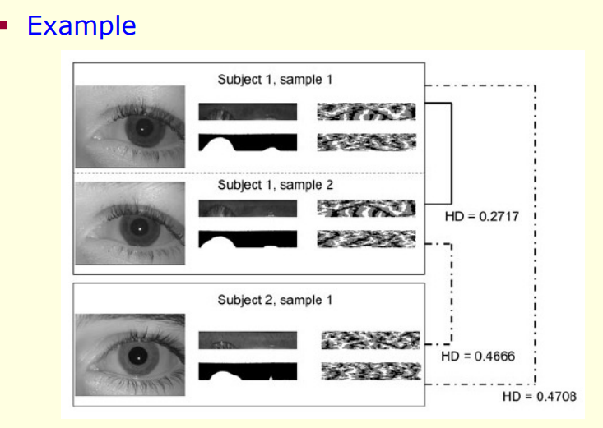
* Smaller HD: Same eye (top)
* Larger HD: different eye (bottom)
* If HD is below a threshold, say that the two iris codes came from the same individual
* 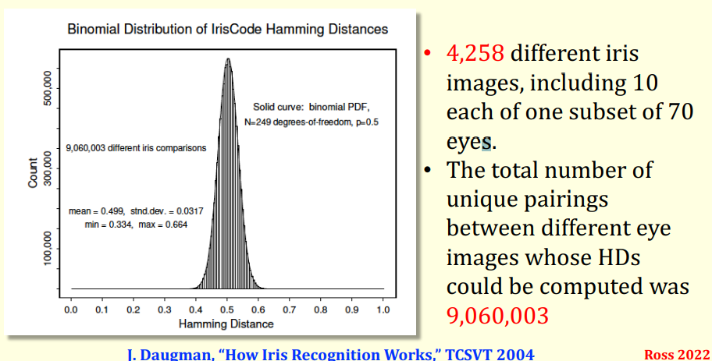
* Biographical: Age, Gender, Race
* Anatomical: Distribution of crypts, Wolfflin nodules, pigmentation spots
* Environmental: Sensor, Illumination wavelength, Indoor/Outdoor
* Pathological: Stromal Atrophy
* Other: Pupil dilation level, Contact Lens
* Presentation Attacks
  + Display
  + Prints
  + Cosmetic Contact
  + Glass
  + Prosthetic
  + Plastic fake eye
* Capturing an iris image often involves cooperation from the user; long-range iris recognition is area of research
* § Iris data of some users may be of poor quality resulting in a failure to enroll
* § Extraction of soft biometric traits from iris is possible: gender, ethnicity, etc.
* § Presentation attack detection and image forensics are important application areas
* § Impact of aging is being studied: conflicting findings reported in the literature
* § Post-mortem iris recognition needed in some cases
* § Deep learning methods are becoming increasingly popular